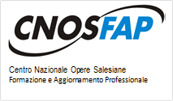
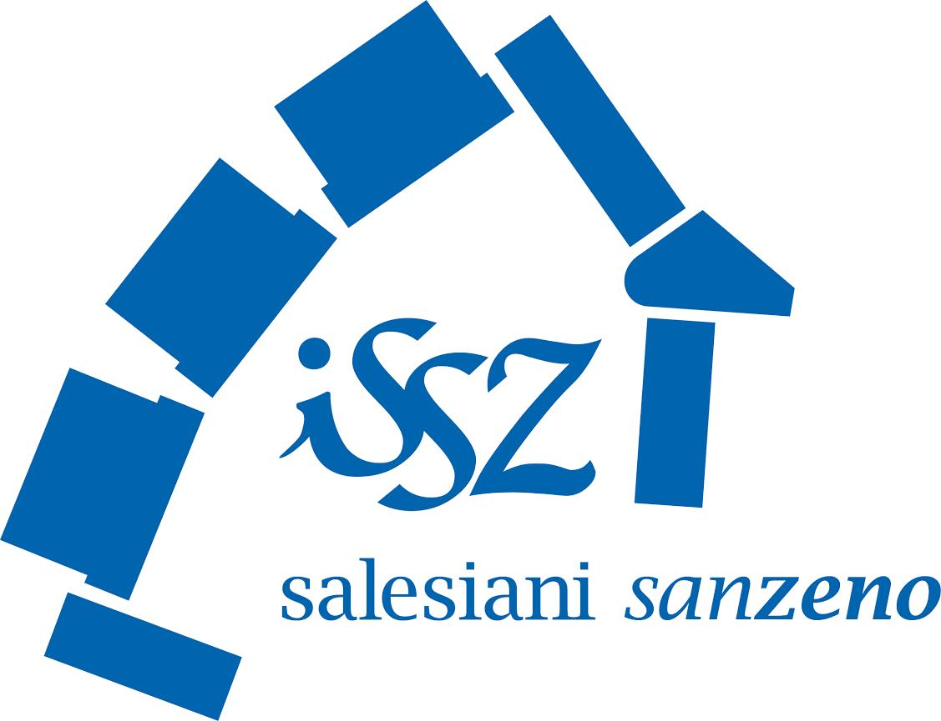
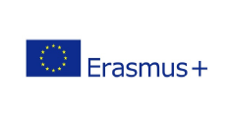
VERONA
VERONA 26 – 30 SEPTEMBER 2016

WELCOME KIT
Programme: ERASMUS +
Project title: Learning to develop skills in stonecutting
KA2 - Cooperation for innovation and exchange of good practices
Action: Strategic partnerships in the field of vocational education and training
Grant Agreement:No.15-202-012635

Annex 1

INVITATION to the 2nd multiplier event in the framework of project »Learning to develop skills in stonecutting« (with acronym EARN), which will be held on
Wednesday, 28th September 2016 at 11:00 am
on the fairground VeronaFiere MARMOMACC in Verona
Viale del Lavoro 8 – 37135 Verona (Italy)

http://www.marmomacc.com/it/

Meeting program:

Time | Event description
11:00 - 11.15  11.15 – 11.30  11.30 – 11.50  11.50 – 12.30  12.30 – 14.00  14.00 – 14.30  14:30 – 14.45  14.45 – 16.00  16.00 – 17.30 | - Registration and coffee  - Greetings, presentation of the purpose of the event, substantive and temporal structure of the event  - Application round - Presentation of the participants and their expectations  - Content, goals and expected results of the project,  - Review and presentation of achieved interim intelectual results  - Lunch  - Preparation for the testing of a new model of practical job training for the stonecutter profession by Slovenian employer  - Break  - Comparison of the curriculum of partner countries, with the aim of strengthening the weak areas in curriculum  - Content, structure and design of manual,  - Review of the results of the event,  - Background and further concrete actions of partners.

We kindly ask you to confirm your attendance via e-mail luca.finelli@sanzeno.org
untill Thursday, 8/9/2016.

Contact address: Associazione C.F.P. Cnos-Fap »San Zeno« Via Don Giovanni Minzoni 50, Italy – 37138 Verona. Contacts: Luca Finelli - luca.finelli@sanzeno.org ; Fabio Grigoli – f.grigoli@sanzeno.org.

